Accessibility Checklist for PowerPoint

Headings
Check | Description
☐ | Create slides based slide templates created from the Master slide
☐ | On each slide write short, concise title headings that include keywords.

Why is this important?
- Most people just scan a page, so headings might be the only information that gets read.
- Screen readers and text-to-speech tools are programmed to find Heading styles.
- People are blind depend on headings for navigation.
- People who have any reading issues depend on headings to:
  - Provide clues about the content
  - Organize content into groups of related ideas
  - Limit bursts of reading to a few paragraphs

How to Use and Modify Slide Templates
The PowerPoint software is designed to enhance a presentation that is typically given in front of audience. When you share your presentation online, the face to face dialog is missing so it is important to use the tools wisely. (1) When you create a new presentation select a design theme that has good contrast. (2) If you find the design theme doesn’t have enough contrast, use the Master slide template to make modifications. This can be found on the View tab. (3) When you create new slides always use the slide templates and enter a title for each slide regardless if you cover up the title on the slide.
Figure 1
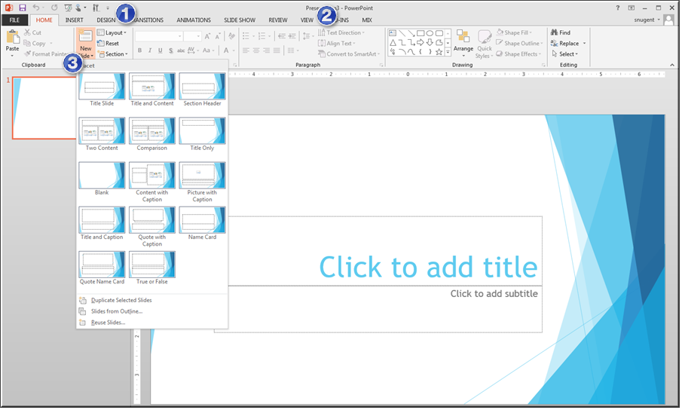

Images
Check | Description
☐ | Add Alt Text to images, diagrams, SmartArt, and tables.
☐ | Write Alt Text that describes what’s important in the image for this article.
☐ | If you included an image for visual emphasis or decoration, write “ “ (Double quote –space – double quote) in the Alt Text title and description. This tells screen reader software to skip over the image, and not describe it for a blind person.
☐ | If the image contains text, repeat the text exactly in the Alt Text description or adjacent content.
☐ | If the image contains text, repeat the text exactly in the Alt Text description or adjacent content.

Why is this important?
- Screen readers read Alt Text out loud.
- Alt Text is the only information that people who are blind have about images and diagrams.
- Blind people depend on Alt Text to explain what the image or diagram communicates. Does it show how something works? Does it show important data?

How to Add Alt Text
All the Microsoft Office programs give images non descriptive names so be sure to update the alt text when adding pictures to a PowerPoint presentation. (1) When you edit a presentation in PowerPoint right click over the image and select Format Picture. (2) In the side panel that displays click the third icon from the left to display the title and alt text options. Write a good description. You can use the same title as the tile if desired.
Figure 2
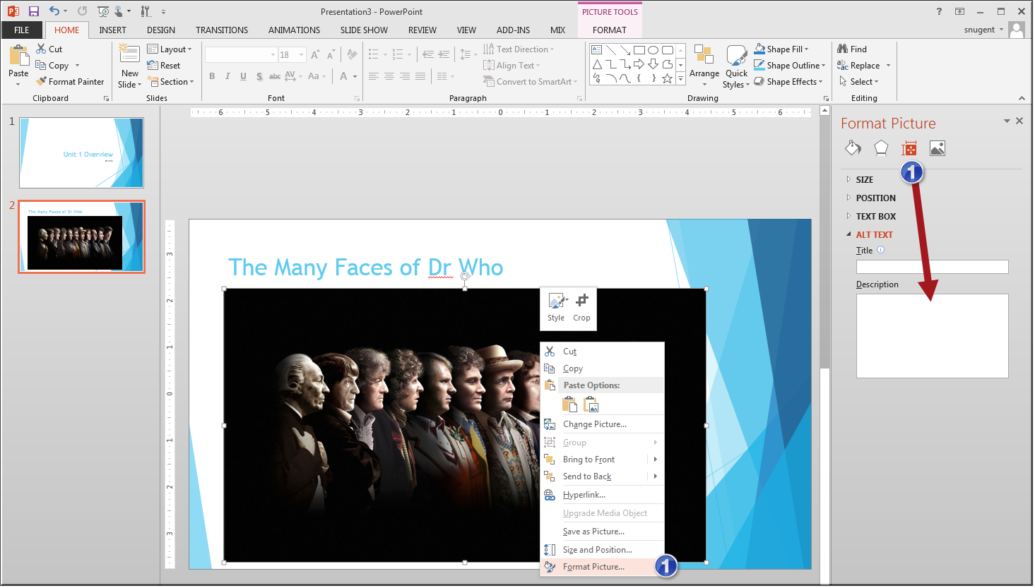

Lists
Check | Description
☐ | Create lists (bulleted and numbered) by using built-in features in slide templates.
☐ | Insert a lead phrase or sentence to introduce the list.
☐ | Make lists that contain related items. If you have to, make more than one list
☐ | Use numbered lists if the order of items is important.
☐ | Use bullet list to organize related items

Why is this important?
- Screen readers and text-to-speech tools are programmed to understand lists that you create with the built-in features. This is especially important for nested lists.
- People who use screen readers appreciate hearing that a list about to be read.
- It’s easier to remember list items if they are related to one another.

How to Add Lists
Open the presentation in PowerPoint. (1) Use the slide template for title and bullets to create a bullet list on a slide. (2) If you choose to create your own text boxes, select the text you wish to be a list and from Home tab in the paragraph group select the bullet or ordered list option. Press the Enter to create another item in the list. In indent a bullet item, press the tab key again or use the indent option on ribbon.
Figure 3
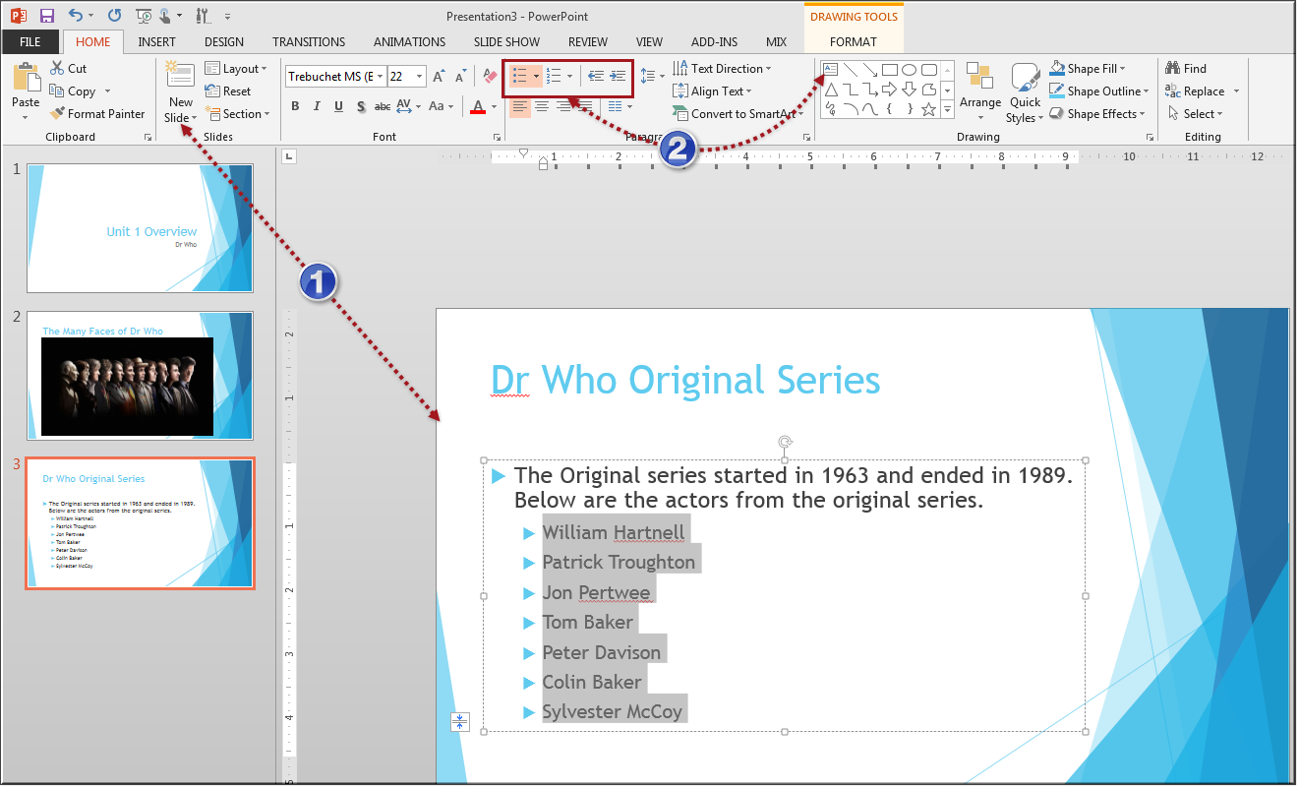

Links
Check | Description
☐ | Give every link meaningful display text.
☐ | Make sure the link display gives a clear idea of the destination and purpose of the link.
☐ | Avoid meaningless phrases such as Click here, and Learn more.

Why is this important?
- If a link does not have meaningful display text, then screen readers read the link URL one character at a time. This can be extremely difficult or impossible to follow while listening.
- If you must use a phrase such as Click here, include some contextual information. For example, use “Click here to see our low sale prices,” or “Click here to try again.”
- Check the destination site. If you can, learn its title and use that in the link display text.

How to Add Links
Open the presentation in PowerPoint. (1) Right-click over the selected text and select Hyperlink. This will display the Insert Hyperlink dialog box where you paste the URL and update the link text. (2) You can also create links from the Insert tab and the Links group.
Figure 4
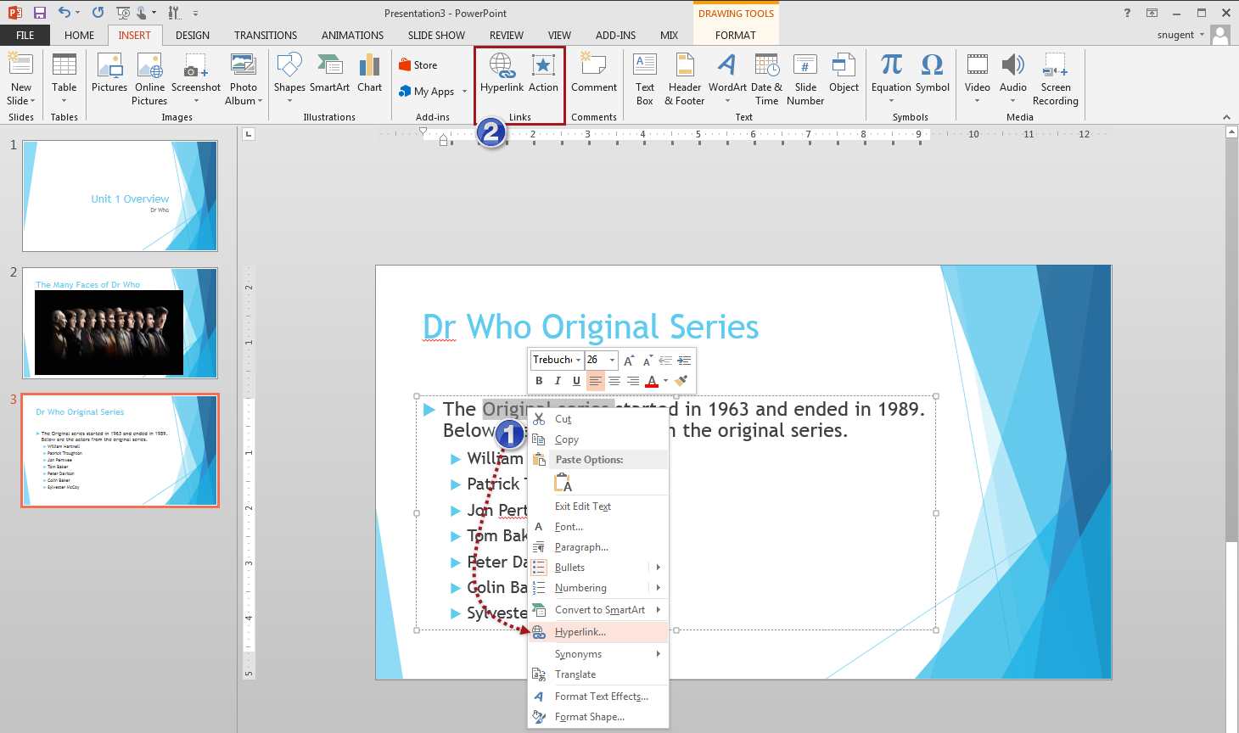

Tables
Check | Description
☐ | Insert tables by using built-in features.
☐ | Use the Tab key to move through the table cells. Make sure the tab order of cells matches the table appearance.
☐ | Make sure that the table has one Header Row.
☐ | Add column labels in the Header Row that describe their contents.
☐ | Fix any merged or split cells in the table.

Why is this important?
- Screen readers and text-to-speech tools are programmed to understand how tables are organized, if you the table by using built-in features.
- Some screen readers can repeat column labels on request. This can be very helpful on large tables with lots of data.
- Screen readers keep track of their location in the table by counting table cells. If a cell is merged or split, then the screen reader loses count. It can’t provide helpful information to the listener any more.

How to Add Metadata to Tables
Be careful how you organize the data in your table. Screen readers will read the content from left to right. (1) Use the Insert tab to create a table or the table icon from slide template. (2) A table is considered an object so you will need to apply alt text to the table. Right-click over the selected table and choose Format Shape. (3) In the side panel select the third icon from the left and add alt text for the table.
Figure 5
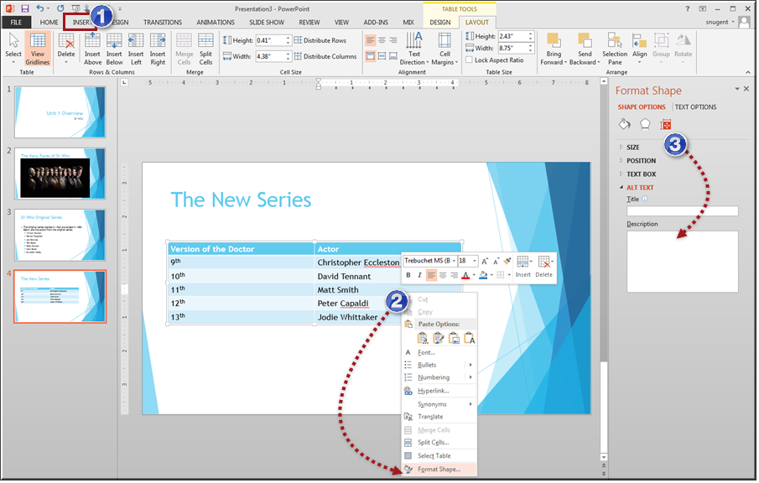

Presentation as a whole
Check | Description
☐ | Use the master slides to format the presentation
☐ | Make sure every slide has a title
☐ | Save the file as a PowerPoint presentation (.pptx).
☐ | Give the file a meaningful name.
☐ | Make sure the filename gives a clue about the presentation contents.
☐ | Add the author’s name and the document title to the document properties on the PowerPoint Backstage.
☐ | Add the author’s name and the document title to the document properties on the PowerPoint Backstage.

Why is this important?
- Screen readers and text-to-speech tools are programmed to find Heading styles
- Master slides provide a consistent design of the slides with proper contrast
- Meaningful file names help people locate the information that they want.
- Some organizations put documents on web sites, and organize it by using information from the document properties. It’s a good idea to make sure your document is ready for this.

How to Run the Accessibility Checker
From the backstage you can run the accessibility checker. (1) Click File > Info > Check for Issues > Check Accessibility. A side panel will display with details about each issue found in the presentation. (2) You can also add metadata to the presentation. (3) Additional settings can be modified from the account and options links in left sidebar.
Figure 6
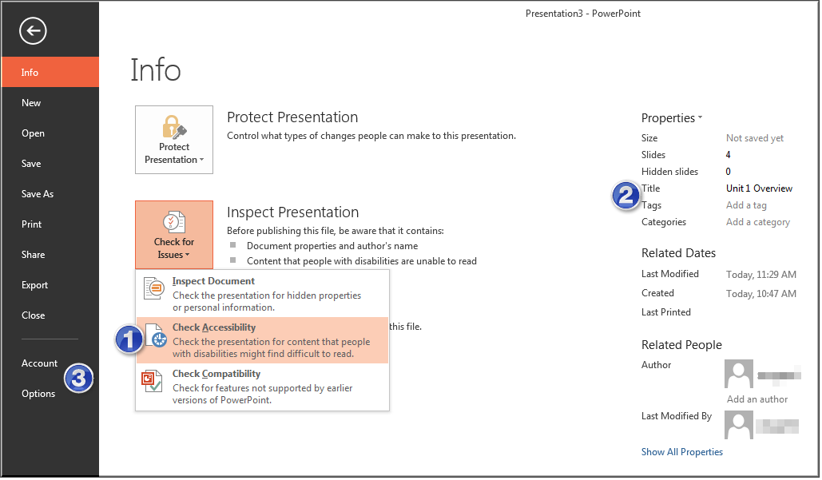

More tips for an accessible Presentation

Fonts
- Use a Sans Serif font.
- Minimize the use of character formats like italics and bold.
- Avoid setting specific sizes because this removes the user’s ability to resize pages with application or browser functions like Zoom.

Alignment
- Use Left-aligned text whenever possible.
- Centered (justified) text creates uneven vertical lines that are very difficult for people with reading disabilities and people with low vision.

Colors
- Use strong contrast between background color and font color
- Never use color alone to indicate information. People who are color-blind might not be able to see the point.

Images and Multimedia
- Make sure all images have alt text
- If images are used for decoration use the double quotes to specify to the screen reader that this image is not important to content.
- If a presentation includes several multimedia items, export the presentation as a video and upload to Canvas using the media comment feature.
- Add captions and/or a word for word text transcript for the exported multimedia

Writing style
- Use short, simple sentences.
- Avoid abbreviations except when the abbreviation is part of common language, like USA or NASA.
- Group related ideas under a heading
- If possible, limit slides to one idea
- Check readability statistics

White space and background
- Allow ample white space between lines and between paragraphs.
- Clearly separate text and background

