Accessibility Checklist for Word

Headings
Check | Description
☐ | Create headings by using built-in styles in Word
☐ | Write short, concise headings that include keywords.
☐ | Write headings that give people good clues about the information that follows them.
☐ | Arrange headings in order – H3 headings under H2, H2 headings under H1, and so on.
☐ | Make sure each heading contains no more than 2-3 paragraphs of content.

Why is this important?
- Most people just scan a page, so headings might be the only information that gets read.
- Screen readers and text-to-speech tools are programmed to find Heading styles.
- People who are blind depend on headings for navigation.
- People who have any reading issues depend on headings to:
  - Provide clues about the content
  - Organize content into groups of related ideas
  - Limit bursts of reading to a few paragraphs

How to Mark Text as Headings
Review each document in your course to be sure each document is structured properly with headings. (1) Open the document in Word. With the Home tab displayed in the ribbon select the text you wish to be a header and from the Styles group select the desired heading. Be sure all heading are in proper order with content arranged logically. If you wish to modify a style, right click over the style in the ribbon and choose modify. (2) You can also use the Design tab to select a different style for your document.
Figure 1
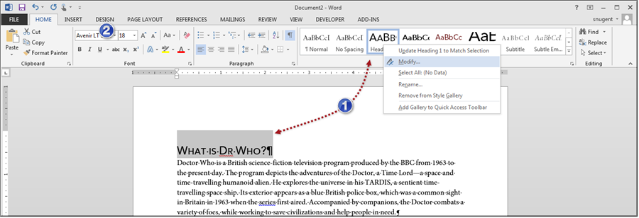

Images
Check | Description
☐ | Add Alternative (Alt) Text to images, diagrams, SmartArt, and tables.
☐ | Write Alt Text that describes what’s important in the image for this document.
☐ | If you included an image for visual emphasis or decoration, write “ “ (Double quote –space – double quote) in the Alt Text title and description. This tells screen reader software to skip over the image, and not describe it for a blind person.
☐ | If the image contains text, repeat the text exactly in the Alt Text description or adjacent content.

Why is this important?
- Screen readers read Alt Text out loud.
- Alt Text is the only information that people who are blind have about images and diagrams.
- Blind people depend on Alt Text to explain what the image or diagram communicates. Does it show how something works? Does it show important data?

How to Add Alt Text to Images
All the Microsoft Office programs give images non descriptive names so be sure to update the alt text when adding pictures to a Word document. (1) When you edit a document in Word right click over the image and select Format Picture. (2) In the side panel that displays click the third icon from the left to display the title and alt text options. Write a good description. You can use the same text for the title if desired.
Figure 2
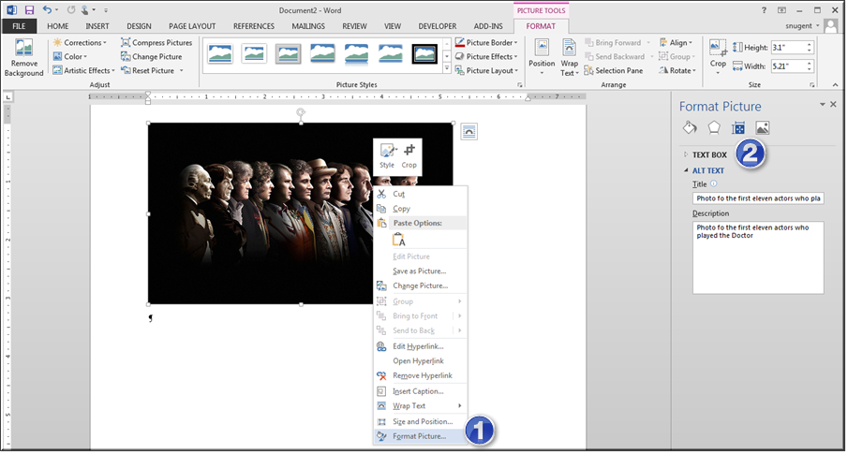

Lists
Check | Description
☐ | Create lists (bulleted and numbered) by using built-in features in Word.
☐ | Insert a lead phrase or sentence to introduce the list.
☐ | Make lists that contain related items. If you have to, make more than one list
☐ | Use numbered lists if the order of items is important.
☐ | Use bullet list to organize related items

Why is this important?
- Screen readers and text-to-speech tools are programmed to understand lists that you create with the built-in features. This is especially important for nested lists.
- People who use screen readers appreciate hearing that a list about to be read.
- It’s easier to remember list items if they are related to one another.

How to Create Lists
Open the document in Word. (1) With the Home tab displayed in the ribbon, select the text you wish to be a list and from the paragraph group select the bullet or ordered list option. (2) Microsoft Word has a feature that allows you create lists on the fly. Place the cursor just before the text that you want to make a list item and press the tab key on the keyboard. This will create a bullet point with the text. Press the Enter to create another item in the list. In indent a bullet item, press the tab key again or use the indent option on ribbon. Press the Enter key twice to end the list.
Figure 3
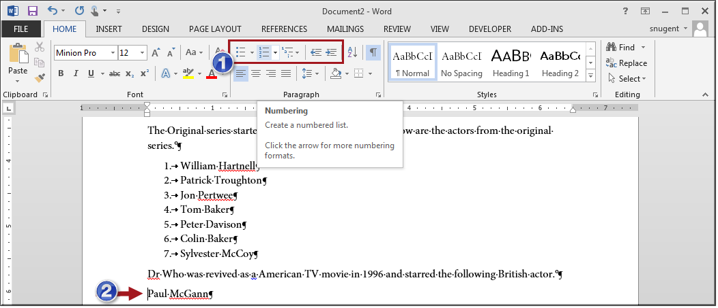

Links
Check | Description
☐ | Give every link meaningful display text.
☐ | Make sure the link display gives a clear idea of the destination and purpose of the link.
☐ | Avoid meaningless phrases such as Click here, and Learn more.
☐ | If your document contains an excessive amount of links, convert the content to a Canvas page.

Why is this important?
- If a link does not have meaningful display text, then screen readers read the link URL one character at a time. This can be extremely difficult or impossible to follow while listening.
- If you must use a phrase such as Click here, include some contextual information. For example, use “Click here to see our low sale prices,” or “Click here to try again.”
- Check the destination site. If you can, learn its title and use that in the link display text.

How to Create Links in Word
Open the document in Word. (1) Right-click over the selected text and select Hyperlink. This will display the Insert Hyperlink dialog box where you paste the URL and update the link text. (2) You can also create links from the Insert tab and the Links group.
Figure 4
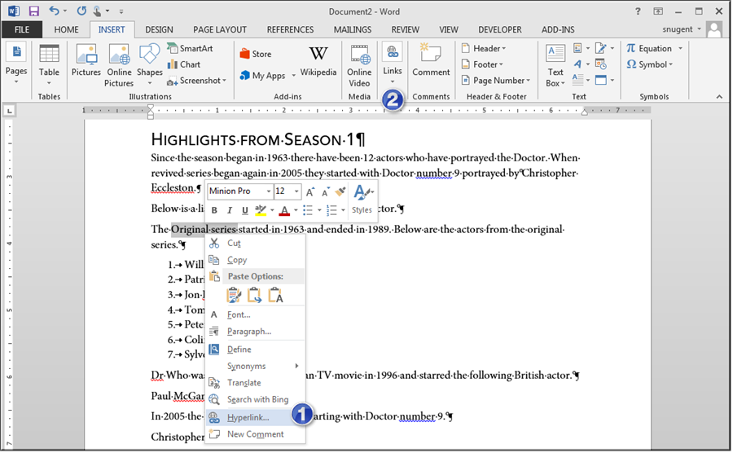

Tables
Check | Description
☐ | Insert tables by using built-in features.
☐ | Use the Tab key to move through the table cells. Make sure the tab order of cells matches the table appearance.
☐ | Make sure that the table has one Header Row.
☐ | Add column labels in the Header Row that describe their contents.
☐ | Fix any merged or split cells in the table.

Why is this important?
- Screen readers and text-to-speech tools are programmed to understand how tables are organized, if you the table by using built-in features.
- Some screen readers can repeat column labels on request. This can be very helpful on large tables with lots of data.
- Screen readers keep track of their location in the table by counting table cells. If a cell is merged or split, then the screen reader loses count. It can’t provide helpful information to the listener any more.

How to Modify a Table
Be careful how you organize the data in your table. Screen readers will read the content from left to right. (1) To select a table click the plus icon in upper left corner of the table. (2) The table tools will display in the ribbon. In the table styles group click the down pointed arrow in lower right corner to display all the table styles. Select the desired table style. (3) Click the Layout tab and select properties from the table group. In the dialog box that appears select the Alt Text tab and add a title and description for the table.
Figure 5
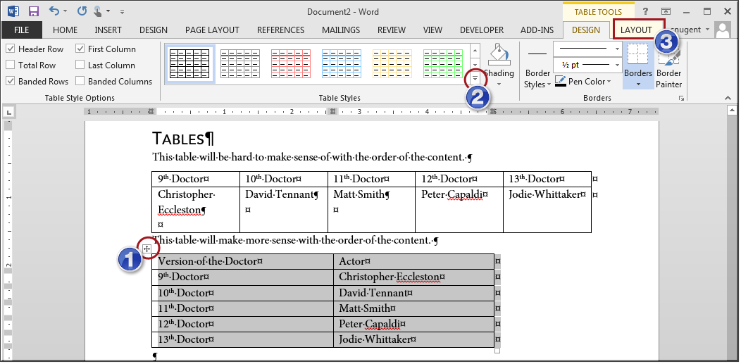

Document as a whole
Check | Description
☐ | Save the file as a Word document (.docx).
☐ | Give the file a meaningful name.
☐ | Make sure the filename gives a clue about the document contents.
☐ | Add the author’s name and the document title to the document properties on the Word Backstage.
☐ | Add the author’s name and the document title to the document properties on the Word Backstage.
☐ | Run the Accessibility Checker from the Backstage Info screen.

Why is this important?
- Meaningful file names help people locate the information that they want.
- Some organizations put documents on web sites, and organize it by using information from the document properties. It’s a good idea to make sure your document is ready for this.

How to Run the Accessibility Checker
From the backstage you can run the accessibility checker. (1) Click File > Info > Check for Issues > Check Accessibility. A side panel will display with details about each issue found in the document. (2) You can also add metadata to the document. (3) Additional settings can be modified from the account and options links in left sidebar.
Figure 6
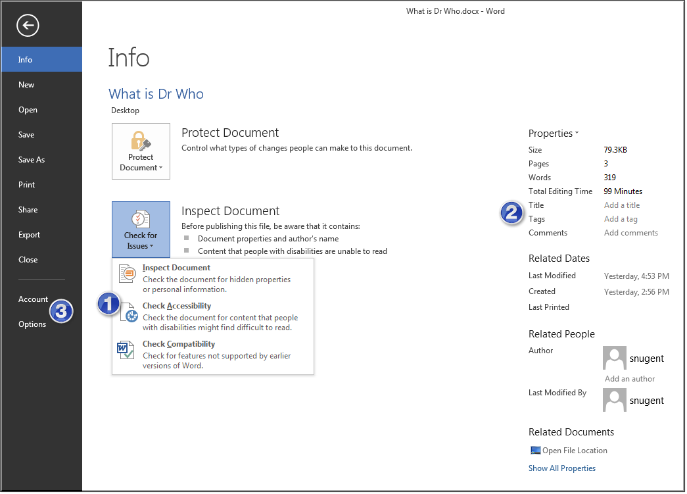

More tips for an accessible document

Fonts
- Use a Sans Serif font.
- Minimize the use of character formats like italics and bold.
- Avoid setting specific sizes because this removes the user’s ability to resize pages with application or browser functions like Zoom.

Alignment
- Use Left-aligned text whenever possible.
- Centered (justified) text creates uneven vertical lines that are very difficult for people with reading disabilities and people with low vision.

Colors
- Use strong contrast between background color and font color
- Never use color alone to indicate information. People who are color-blind might not be able to see the point.

Images and Multimedia
- Make sure all images have alt text
- If images are used for decoration use the double quotes to specify to the screen reader that this image is not important to content.
- Make sure all multimedia has captions and/or a word for word text transcript

Writing style
- Use short, simple sentences.
- Avoid abbreviations except when the abbreviation is part of common language, like USA or NASA.
- Group related ideas under a heading
- If possible, limit paragraphs to one idea
- Check readability statistics

White space and background
- Allow ample white space between lines and between paragraphs.
- Clearly separate text and background

